PANDAS PROGRAMS

AIM
To write a Python program using the Pandas library to create a DataFrame and perform data exploration, statistical analysis, column selection, filtering, and row access using head(), info(), describe(), iloc[], and loc[].

ALGORITHM
- Start the program.
- Import the Pandas library using import pandas as pd.
- Create a dictionary containing the columns Name, Age, and City with the corresponding values.
- Convert the dictionary into a Pandas DataFrame using pd.DataFrame(data).
- Display the first five rows using df.head().
- Display the DataFrame information, including data types and non-null values, using df.info().
- Display the statistical summary using df.describe().
- Select and display the Age column using df['Age'].
- Filter and display the people whose age is greater than 25 using df[df['Age'] > 25].
- Access and display the first row using df.iloc[0].
- Access and display the name at index 0 using df.loc[0, 'Name'].
- Stop the program.

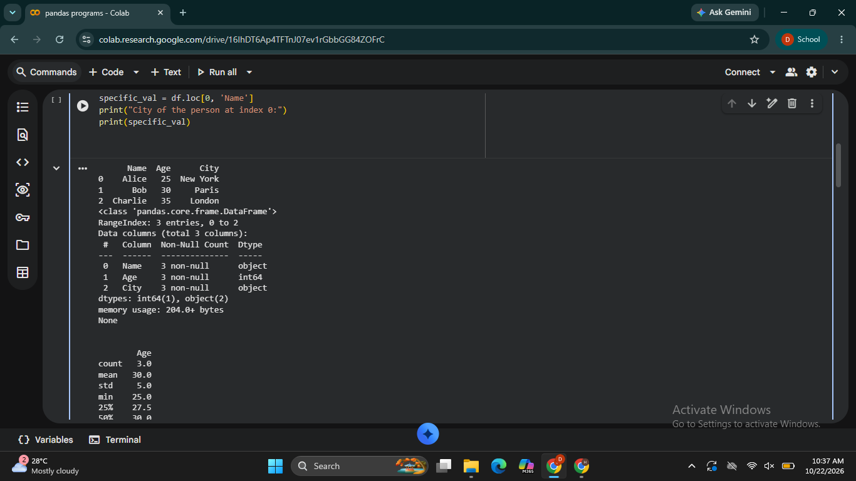
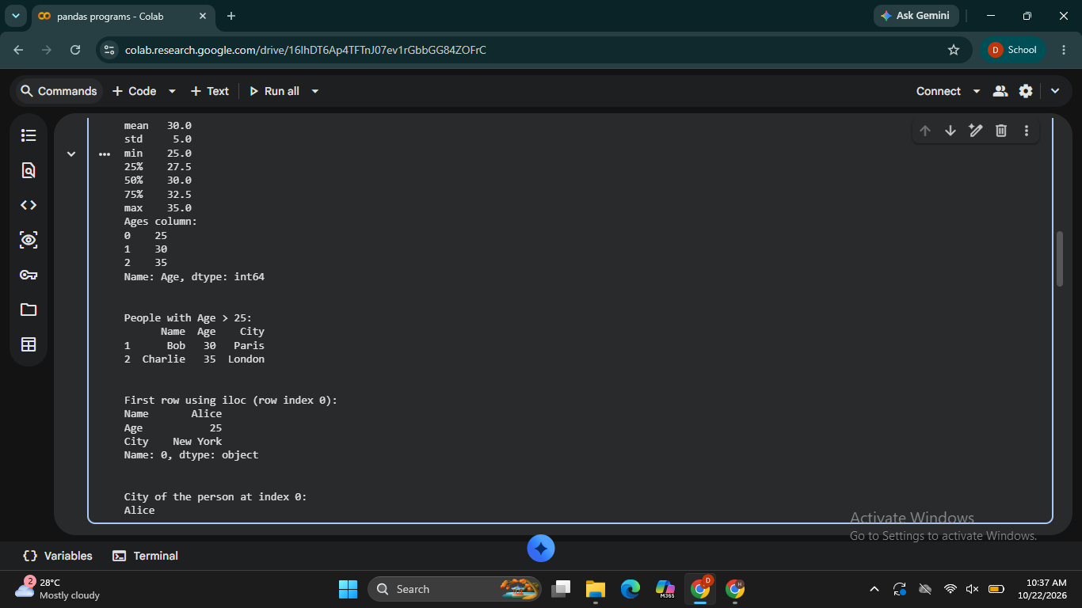

RESULT
Thus, the Python program using Pandas was executed to create and explore a DataFrame, display its statistical summary, select a column, filter rows based on a condition, and access specific rows and values using iloc[] and loc[].

